EXECUTIVE SUMMARY

2008 CARE Workshop

This Executive Summary of the recent 2008 CARE Workshop is appended to the ‘2007 CARE Annual Report to the TSC’ in order to promote timely reporting of work that would otherwise not be reported till 2009, and to facilitate work and action to occur over the remaining year.

Overview
The 2008 CARE Workshop was held April 1-3 in Nanaimo, British Columbia at the Pacific Biological Station (PBS), hosted by Shayne MacLellan and the PBS Sclerochronology Lab staff. A total of 31 individuals representing 7 agencies attended (Table 1). An agenda from this workshop follows under Appendix I-A. This workshop was an active one, highlighted by: substantial group discussion on varied topics; 4 scientific presentations; notable accomplishments made by the working groups; deeper involvement by more CARE members including nomination to working groups and administration positions, especially those not having previously served in these roles; convening of a sablefish age-reading ad hoc working group; and significantly, a unanimous decision by the CARE to shift its biennial meeting cycle to an odd-year rotation opposite of the Western Groundfish Conference. There were no Recommendations made by CARE to the TSC; however, there are four Recommendations made by CARE to itself.

Working Groups and Reports
There were 2 working groups active prior to and reporting at the Workshop. Two additional working groups convened at this workshop, for a total of 4 working groups that will be active during the next rotation.

1. Manual/Glossary Committee, 2006-2008 (MacLellan, Goetz, Munk) – MacLellan reported on work completed from 2006-2008. MacLellan requested that she be replaced as working group lead. Betty Kamikawa (NMFS-NWFSC/PSMFC) will succeed MacLellan as group lead July 1, 2008. Highlights of work completed:
- Shayne MacLellan (CDFO) worked with John Sneva (WDFW) and Lisa Lysak to complete the lingcod and Dover sole CARE manual sections for presentation to CARE membership 2006 meeting. Both sections were approved by membership. Jon Short (NMFS-AFSC) worked with MacLellan to insert the new material seamlessly into the electronic version. Short updated the on-line manual at the CARE website December 2006.
- No progress has been made on developing the hake section for the CARE Manual.
- No new sections for the CARE Manual have been proposed.
- MacLellan, Betty Goetz (NMFS-AFSC) and Kristen Munk (ADFG) developed the wording for the term “dark/light boundary” which was inserted in the CARE Manual glossary section and updated to the CARE website December 2006.

2. Web Committee (Short, Anderl), 2006-2008 – Jon Short (NMFS-AFSC) reported on work completed and used a dynamic link to the CARE website to demonstrate these updates. The CARE website is being upgraded to include user-modifiable tables that also retain data history/succession. For example, the table “Summary of Age Reading Methodology”, previously EXCEL-based and passed from one administration to the next, now resides on the CARE website. Content is searchable. Short requested that he be replaced as the working group lead. Nikki Atkins(NMFS-NWFSC/PSMFC) will commence as co-chair of the web committee along with Short.

3. Charter committee (Munk, MacLellan, Anderl/Goetz) – this working group reconvened to insert recent age structure exchange language into the Charter and make other minor edits, to be completed by the next workshop.

4. Sablefish Age Readers Ad hoc Working Group – The sablefish age readers convened an ad hoc working group to deepen documentation of sablefish age-reading criteria and fundamental differences between stocks from southern to northern extent of the species range. The goals for this group are outlined in Appendix I-B.

Age Structure Exchanges (Vice-chair: MacLellan)
Age structure exchanges were made in 2007 and the early part of 2008. Specifically, in 2007 there were 4 exchanges: hake (2), sablefish, and lingcod fins. In 2008 there were 3 samples exchanged: sablefish (2), and yelloweye rockfish (1). These data are available upon request of the “Coordinator” of the specific exchange sample. Table 2 lists the exchanges made from 2006 to 2008.

Business Session Highlights and Discussion:
- The 2006 CARE Workshop Meeting Minutes were passed, and soon will be uploaded to the CARE website. CARE expressed interest in more promptly approving minutes, and developed a recommendation to itself describing a process facilitating this.
- An informal poll of readers was taken to assess attrition. Readers were asked what their approximate date of departure (retirement, other) from age-reading responsibilities would be. A total of 31 age readers responded (out of a potential 40), over half of whom have “age-reading” as their primary responsibilities (eg, >6mo/y). Fifty-one percent will be departing age reading responsibilities in 10 years or less, with 28% departing in less than 7y, and 19% in less than 5y.
- Additional workshop discussion details will be forthcoming upon completion of the 2008 CARE Workshop Meeting Minutes.

Workshop and Hands-on Session Highlights and Discussion:
- A total of at least 31 readers reviewed 18 species (Figure 1). Session summaries will be transcribed and appended to the 2008 meeting minutes.
- Several readers from CDFO, WDFW, ADFG, and NMFS-NWFSC/PSMFC focused on calibration using recent age structure exchanges. Four structure exchanges occurred prior to the workshop with resolution work at the workshop (Figure 2): sablefish, yelloweye rockfish, hake, and spiny dogfish.
- “Recommendation working groups” focused on wording of CARE recommendations (Figure 3).
- A representative of Buehler demonstrated a production high speed diamond saw (Figure 4).

Recommendations C.A.R.E.~TSC
- 2008 CARE to CARE
  - 2008CC-01 “Move CARE workshop to off-year from Western Groundfish Conference”: The CARE recognizes that their biennial workshop coincides with the biennial Western Groundfish Conference, and that this co-occurrence creates competition for same-year travel money. This can prevent attendance to one or both, and where off-year travel budgets might be underutilized. CARE proposes to move their workshop out of phase to the Western Groundfish Conference. CARE will next convene in 2009, the adjustment year. This will begin the new biennial sequence of 2009, 2011, 2013, etc.
  - 2008CC-02 “Add CARE website disclaimer and citation information”: CARE recommends adding site and citation information to the CARE website. A new link in the sidebar entitled “Site information” will open a page with the following information:
“This website is subject to periodic update and data may not have been formally peer reviewed. If you have specific questions please contact the contributing agencies.”
“If you wish to cite the webpage the following format is suggested: Committee of Age Reading Experts (CARE). “Title of Page.” Date accessed: <access date> <URL>”.
  - 2008CC-03 “Create CARE trial forum”: CARE recommends creating a three-year trial forum for the discussion of age reading topics by the CARE community and other age-reading personnel. Users of the forum would be required to set up a user name and password; anonymous commenting would be disabled. Specific categories would be created for different areas of discussion: Specific species (with Flatfish, Rockfish, Roundfish, Elasmobranches, and Invertebrates as sub-categories), Preparation Methods, Digital Imaging, Equipment, Other and Off Topic. Each user will be able to choose whether they receive e-mail notifications of posts for the entire forum, specific categories/sub-categories, individual discussions, or none at all. Nikki Atkins (NMFS-NWFSC/PSMFC) will act as Moderator of the forums.
  - 2008CC-04 “Expedite approval of meeting-minutes”: CARE recommends expediting their approval of meeting-minutes. The CARE Chair will send an email to workshop participants asking to approve the minutes: Yes or NO. Workshop participants will be given 2 weeks to reply; if “out of office” emails are received by the Chair, the time frame will be extended per their discretion. Prior to approval, meeting-minutes will be sent out for editing/corrections to members (see Charter protocol). Meeting-minutes will not go out for approval until all edits are complete, and, will not be posted without approval.
- 2008 CARE to TSC (none made)
- 2007 CARE to CARE (none made)
- 2007 CARE to TSC (none made)
- 2007 TSC to CARE
  - 2007TC-01 TSC will rely on fishery managers and stock assessment authors to interact directly with their ageing lab supervisors to communicate with CARE for ageing exchanges. TSC appreciates the work of CARE and recognizes that a direct link between the assessment biologist and the ageing lab is the most efficient means of requesting species ageing exchanges.
    - CARE 2008 Response: Acknowledged.
- 2006 CARE to CARE
  - 2006CC-01 The CARE Age Structure Exchange (CASE) table presently identifies inter-agency exchanges occurring on species of interest to the TSC, or other inter-agency calibrations as needed. CARE recommends to itself to modify the CASE table and process. We will continue to track structure exchanges per the CARE Charter, however, we will drop precision test results from the CASE table. We will develop a CASE invoice, accessible on the CARE website. Upon initiating an exchange, the originating agency will contact the CASE coordinator for an exchange id number. The originating agency will conduct the exchange, fill out all information in the CASE invoice, and submit it to the CASE coordinator upon its completion. . The CASE coordinator or designee will update the website to allow linked access within the CASE table. Inclusion of precision statistics is optional.
i. CARE 2008 Response: Mostly done. The CARE website currently does not have access to the CASE invoice or link to pdfs of data.
  - CARE recommends making changes to the Summary of Age Reading Method, regarding format and information included. The current table info will be split into two tables; one to include “Methods” information (agency, species, method, validation, area, structure, validation & validation citation). The method, validation and citation columns would provide anecdotal information that will be updated. The method column would include all methods used historically or currently and provide dates when methods were adopted. The validation column would indicate method and extent (e.g. all ages, up to age 30, longevity) and the validation citation column would indicate dates and contact. The new 2nd table would include agency, species, calendar year and number of fish per species aged. Total fish and total species aged would be calculated. Numbers of readers involved per calendar year for all fish aged will also be included. It is recommended that this data would reside on the website and that a small relational database would house the data. A mechanism would be developed to query the database to assess the breadth and depth of expertise for species by agency for all species aged. Development of database will be in small steps. The Vice-chair will be responsible for updating both tables on an annual basis.”
    - CARE 2008 Response: Mostly done. Underlined elements are incomplete or have been dropped.
- 2006 CARE to TSC
  - The biennial CARE meetings have been held traditionally at the Seattle NMFS-AFSC facilities. The Pacific Biological Station (PBS), Nanaimo representatives offered to host the 2008 CARE meeting. Two reasons were given for this proposed departure. First, this invitation coincides with the PBS 100th anniversary (1908-2008). Second, agency travel policies can prohibit age readers from different participating agencies and labs to attend the CARE meeting at the Seattle AFSC facilities. The CARE requests TSC members to support this recommendation and encourage travel funding. This rotation will allow PBS to share in the hosting responsibilities and for greater CARE participation among their personnel. It would also appropriately acknowledge PBS’s substantial contributions to the field of fish age and growth.
    - CARE 2008 Response: Accomplished.
- 2006 TSC to CARE (none made)

Table 1. Attendees of the 2008 CARE Workshop, April 1-3, 2008, Nanaimo, British Columbia.

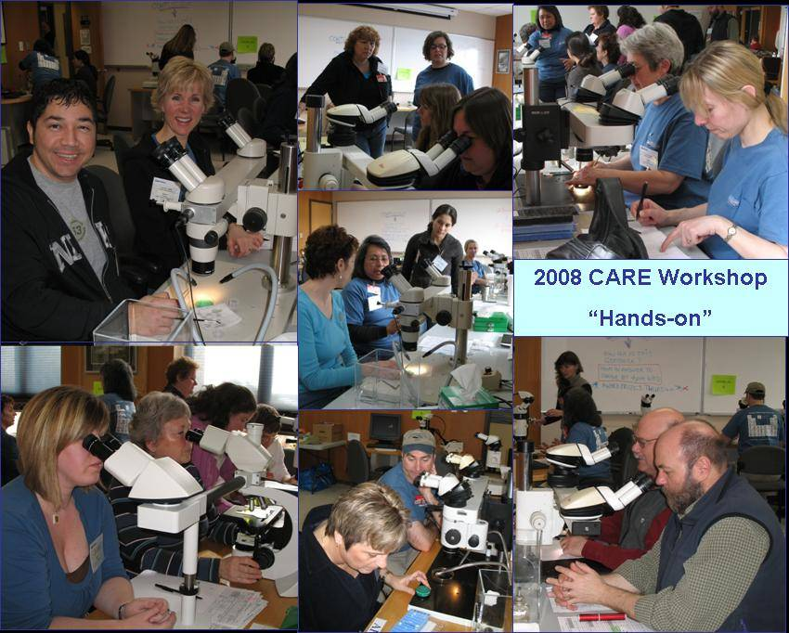
Figure 1. CARE attendees examine growth patterns and resolve differences in their interpretation.

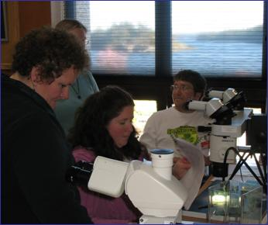
Figure 2. Sablefish age readers Karen Charles (CDFO), Nikki Atkins and Patrick McDonald (NMFS-NWFSC/PSMFC), and Jodi Neil (ADFG; seated) concentrate on calibrating and resolving differences from an age structure exchange (and ignoring the sunny spring day outside).
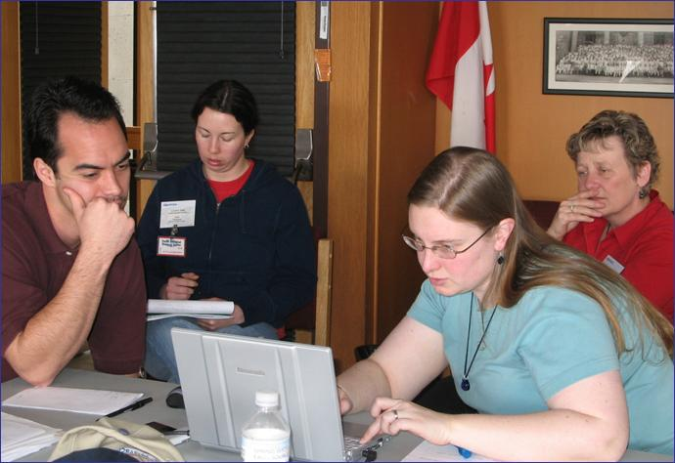
Figure 3. CARE members Jon Short (NMFS-AFSC), Josie Thompson (ODFW), Darlene Gillespie (CDFO), and Nikki Atkins (NMFS-NWFSC; at laptop) craft wording of a CARE to CARE recommendation.

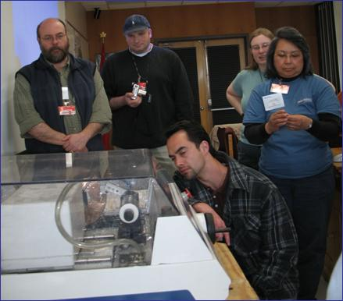
Figure 4. Willy Dunne (ADFG), Chris Gburski (NMFS-AFSC), Nikki Atkins (NMFS-NWFSC/PSMFC), Delsa Anderl and Jon Short (NMFS-AFSC) observe a demonstration of a production high speed cutting machine.

